HOSTING A WEBSITE FOR A FABRICATION COMPANY

***A mini project report submitted by***

**REVANTH VADDI (URK20CS2042)**

***in partial fulfilment for the award of the degree of***

**BACHELOR OF TECHNOLOGY**

***in***

**COMPUTER SCIENCE AND ENGINEERING**

***under the supervision of***

**DR. R. PRISCILLA JOY**

**Assistant Professor**



**DEPARTMENT OF COMPUTER SCIENCE AND ENGINEERING**

**KARUNYA INSTITUTE OF TECHNOLOGY AND SCIENCES**

(Declared as Deemed-to-be-under Sec-3 of the UGC Act, 1956)

**Karunya Nagar, Coimbatore - 641 114. INDIA**

**OCTOBER 2022**



**DEPARTMENT OF COMPUTER SCIENCE AND ENGINEERING**

**BONAFIDE CERTIFICATE**

This is to certify that the project report entitled, “**Hosting a Website for a Fabrication Company”** is a bonafide record of Mini Project work done during the odd semester of the academic year 2022-2023 by

**REVANTH VADDI (Reg. No: URK20CS2042)**

in partial fulfillment of the requirements for the award of the degree of Bachelor of Technology in Computer Science and Engineering of Karunya Institute of Technology and Sciences.

Submitted for the Viva Voce held on

**Project Coordinator Signature of the Guide**

**ACKNOWLEDGEMENT**

First and foremost, I praise and thank the ALMIGHTY GOD whose blessings have bestowed upon me the will power and confidence to carry out my project. I am grateful to our beloved founders Late**. Dr. D.G.S. Dhinakaran, C.A.I.I.B, Ph.D.,** and **Dr. Paul Dhinakaran, M.B.A, Ph.D.**, for their love and always remembering us in their prayers. I extend my thanks to our Vice Chancellor **Dr.P. MannarJawahar, Ph.D.** and our Registrar **Dr. Elijah Blessing, M.E., Ph.D.,** for giving me this opportunity to do the project. I would like to thank **Dr. Prince Arulraj, M.E., Ph.D.,** Dean, School of Engineering and Technology for his direction and invaluable support to complete the same. I would like to place my heart-felt thanks and gratitude to **Dr. J. Immanuel John Raja, M.E., Ph.D.** Head of the Department, Computer Science and Engineering for his encouragement and guidance.

I feel it an immense pleasure to be indebted to, **Dr. R. Priscilla Joy** **Assistant Professor,** Department of Computer Science and Engineering for the invaluable support, advice and encouragement. I also thank all the staff members of the Department for extending their helping hands to make this project a successful one.

I would also like to thank all my friends and my parents who have been supportive and prayed and helped me during the project work.

|  |  |  |
| --- | --- | --- |
|  | **TABLE OF CONTENTS** |  |
| Acknowledgement |  | 3 |
| Abstract |  | 5 |
| **1. Introduction** |  |  |
| 1.1 Introduction |  | 6 |
| 1.2 Objectives |  | 7 |
| 1.3 Motivation |  | 7 |
| **2. Analysis and Design** |  |  |
| 2.1 Requirements | 8 | |
| 2.2 Architecture  2.3 Use case diagram | 9  10 | |
| 2.4 Sequence diagram | 11 | |
| **3. Implementation** |  |  |
|  |  | |
| 3.1. Importing libraries | 12 | |
| 3.2. Coding | 13 – 23 | |
| 3.3. Tools used | 24 | |

1. **Screenshots** 25 – 29
   1. Results 30
2. Conclusions and Future Scope 30
3. References 31

**ABSTRACT**

There are many startup companies that don’t have a proper website. They need a website to showcase their works and to market themselves. They need to know their customers. They are interested to have a website but as it is a startup, they don’t give much preference to the website. My project helps one such company called Revanth Fabricators Private Limited which is a Fabrication based company in Hyderabad. The company provides High-End Fabrication and Engineering Works around India. So, my Project is a Live Project, A Website that displays the company Profile When it started, what are their objectives, Unique Factors that differentiate the company from other Fabrication Units, the services it provides Major Past Projects, Achievements, and Locating Customers to their Factory. A website that is Attractive and Features Rich. The website also contains a form that customers who are interested to get the products or services, People who are interested in getting a call from the company can fill the form, and through API, the form Data is sent to Google Sheets where a normal employee in the company who is not that expertise in Database can access the Data and Call the customers and get to what they want. This website is made for the ease of the customers to know about the company and order a call from the company and it is made easy for the company to contact the customers by directly adding the form data into Google Sheets where it can be accessed only through certain employees of the company.

**CHAPTER -1**

**INTRODUCTION**

* 1. **Introduction**

Fabrication companies play an important role in society. To make anything possible with metals we need fabrication companies who engineer the metals so that we can get material with perfect sizing and precision. In day-to-day life, we don’t notice but we use many things which are from fabrication companies from the roofs of buildings to supporters on stairs, structure holders for lifts, Structures for Solar Panels, basic iron ladders, water, and milk tankers, barriers, pedestrian barriers and many more. These are the objects which are helpful in day-to-day life. There are many fabrication companies coming up day by day. But these companies need a platform to showcase their work, know their customers, a platform to let people know their vision, mission, services they offer, and many more. So I designed a Website for the company using HTML, CSS, Bootstrap, and JavaScript. I connected the form to Google- Sheets using API so that the customer who needs the service or who needs a call from the company can fill out the form and request a call from the company. The customer details are stored in Google Spreadsheets where the Company can access the sheets and contact their customers for getting orders. This is a live project for a Hyderabad-based Start-Up in Fabrication which was started on 30 June 2018 called Revanth Fabricators Private Limited. The location for the production unit of the company has been placed on the website so that if any customer wants to visit and inspect the production unit they can be directed directly to the company. This live project will benefit the company in its marketing and getting orders.

* 1. **Objectives**

**Objectives**

* + 1. To create a website for a fabrication company.
    2. To display company details
    3. To get details of people who want to contact the company in spreadsheets.
  1. **Motivation**

**Motivation**

Every company needs a website to showcase the products/services they provide. They also need the list of people who are interested in their product but new startups don’t prefer to hire or pay monthly for a new website. So, providing them with a Basic Website that fulfills their needs can help the startups grow.

**CHAPTER -2**

**ANALYSIS AND DESIGN**

* 1. **Requirements**

**Requirements**

**VS Code**

Where we can interpret a high-level and general-purpose programming language. HTML, CSS, BOOTSTRAP, JAVASCRIPT code readability with its notable use of significant indentation

**HTML**

HTML (HyperText Markup Language) is the code that is used to structure a web page and its content, using html it is possible to create static pages with text, headings, tables, lists, images, links.

**CSS**

CSS is responsible for the text style, size, positioning, color, and more on a website. It’s also what controls how a website’s style shifts between desktop and mobile versions.

**BOOTSTRAP**

Bootstrap is a free, open source front-end development framework for the creation of websites and web apps. Designed to enable responsive development of mobile-first websites, Bootstrap provides a collection of syntax for template designs

**JAVASCRIPT**

JavaScript is a text-based programming language used both on the client-side and server-side that allows you to make web pages interactive. Where HTML and CSS are languages that give structure and style to web pages, JavaScript gives web pages’ interactive elements that engage a user.

* 1. **Architecture**

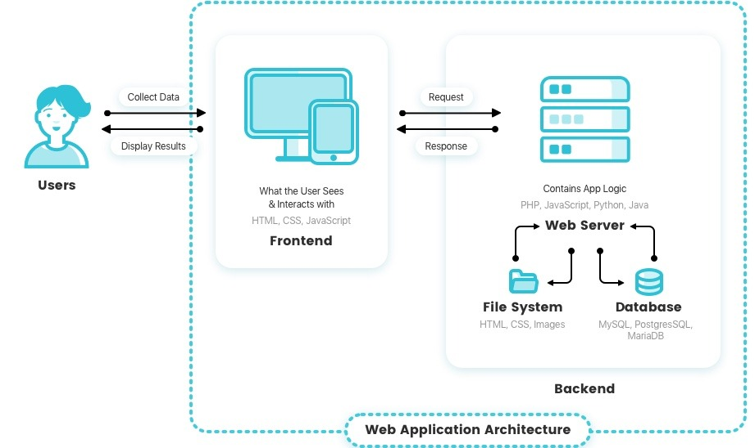

Fig-0: Architecture Diagram

In the front end, we have used HTML, CSS, and BOOTSTRAP.

In the backend, we have used JS and connected to Google Sheets where all the details of the customer entered will be stored in the file through API which can be later accessed easily to contact them for taking orders.

The user can book the service by entering their name, email and phone number.

**2.3 Use case diagram**

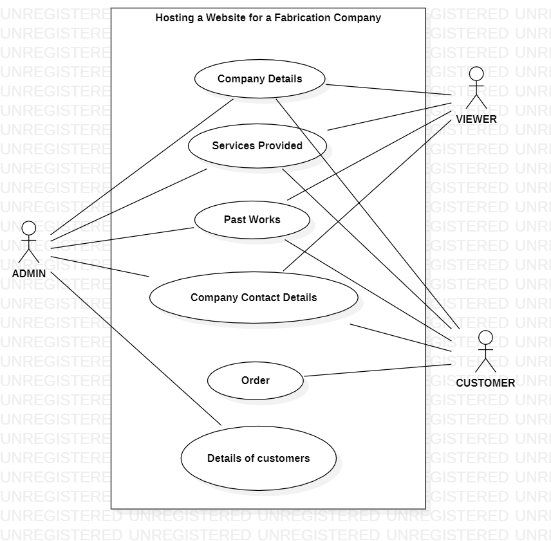

Fig – 1: Use case diagram for website

* 1. **Sequence Diagram**

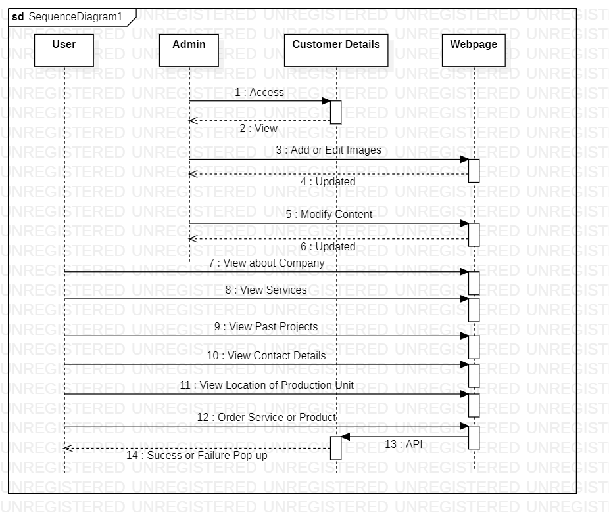

Fig – 2: Sequence Diagram

**CHAPTER -3**

**IMPLEMENTATION**

* 1. **Importing Libraries**

**Importing Libraries**

The libraries required for this project are

* <https://cdnjs.cloudflare.com/ajax/libs/font-awesome/5.15.4/css/all.min.css>
* <https://cdn.jsdelivr.net/npm/bootstrap@5.2.0/dist/css/bootstrap.min.css>
* <https://cdn.jsdelivr.net/npm/bootstrap@5.2.0/dist/js/bootstrap.bundle.min.js>
* <https://unpkg.com/aos@next/dist/aos.css>
* <https://ajax.googleapis.com/ajax/libs/jquery/3.6.0/jquery.min.js>
* <https://api.apispreadsheets.com/data/AiUHMvgS5twFiysZ/>
* <https://fonts.googleapis.com/css2?family=Poppins:wght@100;200;300;400;600;700&display=swap>
  1. **Coding:**

**HTML**

<!DOCTYPE html>

<html lang="en">

<head>

<meta charset="UTF-8">

<meta http-equiv="X-UA-Compatible" content="IE=edge">

<meta name="viewport" content="width=device-width, initial-scale=1.0">

<title>Revanth Fabricators Private Limited</title>

<link rel="stylesheet" href="css/style.css">

<link rel="stylesheet" href="https://cdnjs.cloudflare.com/ajax/libs/font-awesome/5.15.4/css/all.min.css">

<link href="https://cdn.jsdelivr.net/npm/bootstrap@5.2.0/dist/css/bootstrap.min.css" rel="stylesheet"

integrity="sha384-gH2yIJqKdNHPEq0n4Mqa/HGKIhSkIHeL5AyhkYV8i59U5AR6csBvApHHNl/vI1Bx" crossorigin="anonymous">

<script src="https://cdn.jsdelivr.net/npm/bootstrap@5.2.0/dist/js/bootstrap.bundle.min.js"

integrity="sha384-A3rJD856KowSb7dwlZdYEkO39Gagi7vIsF0jrRAoQmDKKtQBHUuLZ9AsSv4jD4Xa"

crossorigin="anonymous"></script>

<link rel="stylesheet" href="aos-by-red.css">

<link rel="stylesheet" href="https://unpkg.com/aos@next/dist/aos.css" />

<script src="https://ajax.googleapis.com/ajax/libs/jquery/3.6.0/jquery.min.js"></script>

</head>

<body>

<!-- navbar sections starts -->

<header class="header">

<div class="logo">

<img src="C:\Users\admin\OneDrive\Desktop\Responsive-Landing-Page-Website-master\images\logo.png" alt="logo-RFPL" height="100px" width="200px">

</div>

<nav class="navbar">

<a href="Home.html">Home</a>

<a href="services.html">Services</a>

<a href="works.html">Our Works</a>

<a href="#footer">Contact</a>

<a class="btn" onclick="openForm()">Book Now!</a>

</nav>

<div class="fas fa-bars" id="menu-btn"></div>

</header>

<!-- navbar sections ends -->

<section>

<div class="container-fluid">

<div id="carouselExampleIndicators" class="carousel slide" data-bs-ride="true">

<div class="carousel-indicators">

<button type="button" data-bs-target="#carouselExampleIndicators" data-bs-slide-to="0"

class="active" aria-current="true" aria-label="Slide 1"></button>

<button type="button" data-bs-target="#carouselExampleIndicators" data-bs-slide-to="1"

aria-label="Slide 2"></button>

<button type="button" data-bs-target="#carouselExampleIndicators" data-bs-slide-to="2"

aria-label="Slide 3"></button>

</div>

<div class="carousel-inner">

<div class="carousel-item active">

<img src="C:\Users\admin\OneDrive\Desktop\Responsive-Landing-Page-Website-master\images\3d-house-with-solar-pannels.jpg" class="d-block w-100" alt="...">

</div>

<div class="carousel-item">

<img src="C:\Users\admin\OneDrive\Desktop\Responsive-Landing-Page-Website-master\images\structural-glass-ceiling.jpg" class="d-block w-100" alt="...">

</div>

<div class="carousel-item">

<img src="C:\Users\admin\OneDrive\Desktop\Responsive-Landing-Page-Website-master\images\large-steel-factory-warehouse.jpg" class="d-block w-100" alt="...">

</div>

</div>

<button class="carousel-control-prev" type="button" data-bs-target="#carouselExampleIndicators"

data-bs-slide="prev">

<span class="carousel-control-prev-icon" aria-hidden="true"></span>

<span class="visually-hidden">Previous</span>

</button>

<button class="carousel-control-next" type="button" data-bs-target="#carouselExampleIndicators"

data-bs-slide="next">

<span class="carousel-control-next-icon" aria-hidden="true"></span>

<span class="visually-hidden">Next</span>

</button>

</div>

</div>

</section>

<!-- home section stars -->

<section class="home" id="home" style="padding-top: 0;" >

<div class="content" data-aos="fade-right" >

<h1>Revanth Fabricators Pvt.Ltd</h1>

<p>A elite fabrication unit which offers high quality services at a profitable prices</p>

</div>

<div class="image">

<img src="C:\Users\admin\OneDrive\Desktop\Responsive-Landing-Page-Website-master\images\male-working-with-welding-torch.jpg" alt="illustration-hero">

</div>

</section>

<!-- home section ends -->

<!-- services sectin starts -->

<section class="services" id="services" >

<div class="heading" data-aos="fade-up" >

<h1>Services</h1>

<p>We Provide High Quality Fabrication and Enigneering Works in a Huge Quantity in short amount of time. We have High Presicion Equipment for accurate punchings, cuttings. </p>

</div>

<div class="row">

<!-- 1 Tab -->

<div class="image">

<img src="C:\Users\admin\OneDrive\Desktop\Responsive-Landing-Page-Website-master\images\picture1.jpg" alt="fabrication-pic">

</div>

<div class="content" data-aos="fade-left">

<h1>It is a Brand!!</h1>

<p>We are offering our quality services all around India since 2018.</p>

</div>

<!-- 1 Tab -->

<!-- 2 Tab -->

<div class="content" data-aos="fade-right">

<h1>Quality First !</h1>

<p>We have High Class Equipment with top skilled Workers. We have one of the biggest metal cutting machines. We use quality products only for saftey of our workers and customers</p>

</div>

<div class="image">

<img src="C:\Users\admin\OneDrive\Desktop\Responsive-Landing-Page-Website-master\images\standard-quality-control-collage.jpg" alt="illustration-features-tab-2">

</div>

<!-- 2 Tab -->

<div class="image">

<img src="C:\Users\admin\OneDrive\Desktop\Responsive-Landing-Page-Website-master\images\businessman-holding-hour-glass-signifies-importance-being-time.jpg" alt="illustration-features-tab-3">

</div>

<div class="content" data-aos="fade-left">

<h1>Always on Time!</h1>

<p>We deilver or services on time. We provide you an accurate date by when we will deliver and do the same on time!</p>

</div>

<!-- 3 Tab -->

</div>

</section>

<!-- services section ends -->

<!-- downloads section starts -->

<section class="download" id="download">

<div class="heading" data-aos="fade-up">

<h1>KNOW US MORE </h1>

</div>

<div class="box-container">

<div class="box" data-aos="fade-right" id="b1">

<img src="C:\Users\admin\OneDrive\Desktop\Responsive-Landing-Page-Website-master\images\Teamwork-of-tiny-people-with-gears-and-cogwheels.jpg" alt="logo-chrome" height="auto" width="300px">

<br><br><br><br>

<h3>Our Services</h3>

<p>What Services we Provide?</p>

<a href="services.html" class="all-btn1">More Info</a>

</div>

<div class="box" data-aos="fade-down" id="b2">

<img src="C:\Users\admin\OneDrive\Desktop\Responsive-Landing-Page-Website-master\images\location.jpg" alt="logo-chrome" height="auto" width="200px">

<h3>Location</h3>

<p>Take a look at our production unit</p>

<a href="https://goo.gl/maps/s1nUa8X9BYrfDvQw5" target="_blank" class="all-btn2">More Info</a>

</div>

<div class="box" data-aos="fade-left" id="b3">

<img src="C:\Users\admin\OneDrive\Desktop\Responsive-Landing-Page-Website-master\images\Checklist.jpg" alt="logo-opera" height="200px" width="300px">

<h3>Past Works</h3>

<p>What are our previous major projects?</p>

<a href="works.html" class="all-btn3">More Info</a>

</div>

</div>

</section>

<!-- downloads section ends -->

<!-- footer section starts -->

<section class="footer" id="footer">

<div class="box-container" data-aos="fade-up">

<div class="box">

<h3>quick links</h3>

<a href="Home.html"><i class="fas fa-chevron-right"></i>home</a>

<a href="services.html"><i class="fas fa-chevron-right"></i>services</a>

<a href="works.html"><i class="fas fa-chevron-right"></i>past works</a>

<a href="#footer"><i class="fas fa-chevron-right"></i>contact</a>

</div>

<div class="box">

<h3>our services</h3>

<a href="#"><i class="fas fa-chevron-right"></i>Cutting and Welding</a>

<a href="#"><i class="fas fa-chevron-right"></i>Metal Punching</a>

<a href="#"><i class="fas fa-chevron-right"></i>Solar Panel Structure</a>

<a href="#"><i class="fas fa-chevron-right"></i>Galvanizing</a>

<a href="#"><i class="fas fa-chevron-right"></i>Site Installation</a>

</div>

<div class="box">

<h3>contact info</h3>

<a href="#"><i class="fas fa-phone"></i>+91 9849093761</a>

<a href="#"><i class="fas fa-phone"></i>+91 8886961117</a>

<a href="#"><i class="fas fa-envelope"></i>Rfpl@gmail.com</a>

<a href="https://goo.gl/maps/zsWCakbhNP7M5pat6"><i class="fas fa-map-marker-alt"></i>Hyderabad, India - 500051</a>

</div>

<div class="box">

<h3>follow us</h3>

<a href="#"><i class="fab fa-facebook-f"></i>facebook</a>

<a href="#"><i class="fab fa-instagram"></i>instagram</a>

<a href="#"><i class="fab fa-linkedin"></i>linkedin</a>

</div>

</div>

<div class="credit"> For

<a href="" target="_blank"><span>Revanth Fabricators Private Limited</span> | all rights reserved</a>

</div>

</section>

<!-- footer section ends -->

<!-- The form -->

<div class="form-popup" id="myForm">

<form id="contForm" class="form-container">

<h1>We will contact you Back!!</h1>

<label for="name"><b>Name</b></label><br/>

<input type="text" placeholder="Enter Name" name="name" id="name" required /><br/>

<label for="email"><b>Email</b></label><br/>

<input type="text" placeholder="Enter Email" name="email" id="email" required /><br/>

<label for="psw"><b>Phone Number</b></label><br/>

<input type="text" placeholder="Enter Phone Number" name="phone" id="phone" required /><br/>

</form>

<div class="form-container"><button class="btn" onclick="SubForm()">Contact Me</button><br/>

<button class="btn cancel" onclick="closeForm()">Close</button><br/>

</div>

</div>

<script src="js/main.js"></script>

<script src="https://unpkg.com/aos@next/dist/aos.js"></script>

<script>

AOS.init({

duration: 2000,

once: true,

});

</script>

</body>

</html>

**CSS:**

*{

font-family: 'Poppins', sans-serif;

margin: 0;

padding: 0;

box-sizing: border-box;

outline: none;

border: none;

text-transform: capitalize;

transition: 0.2s ease-in-out;

color: #000;

text-decoration: none;

}

::selection{

background-color: var(--Soft-Red);

color: #fff;

}

.carousel-inner .carousel-item img{

height: 500px;

}

.carousel-indicators{

background-color: transparent;

}

.carousel-control-prev{

background-color: transparent;

}

.carousel-control-next{

background-color: transparent;

}

::-webkit-scrollbar{

width: 12px;

}

::-webkit-scrollbar-thumb{

background-color: var(--Soft-Blue);

}

section {

padding: 2rem 9%;

}

html{

font-size: 62.5%;

scroll-behavior: smooth;

overflow-x: hidden;

}

.heading{

text-align: center;

font-size: 2rem;

color: var(--Very-Dark-Blue);

margin-top: 10rem;

margin-bottom: 5rem;

}

.heading h1{

padding-bottom: 2rem;

}

.heading p{

max-width: 60rem;

margin: auto;

color: var(--Grayish-Blue);

font-size: 1.7rem;

}

/* The popup form - hidden by default */

.form-popup {

display: none;

position: fixed;

bottom: 0;

right: 15px;

border: 3px solid #f1f1f1;

z-index: 9;

}

/* Add styles to the form container */

.form-container {

max-width: 300px;

padding: 10px;

background-color: white;

}

/* Full-width input fields */

.form-container input[type=text], .form-container input[type=password] {

width: 100%;

padding: 15px;

margin: 5px 0 22px 0;

border: none;

background: #f1f1f1;

}

/* When the inputs get focus, do something */

.form-container input[type=text]:focus, .form-container input[type=password]:focus {

background-color: #ddd;

outline: none;

}

/* Set a style for the submit/login button */

.form-container .btn {

background-color: #04AA6D;

color: white;

padding: 16px 20px;

border: none;

cursor: pointer;

width: 100%;

margin-bottom:10px;

opacity: 0.8;

}

/* Add a red background color to the cancel button */

.form-container .cancel {

background-color: red;

}

/* Add some hover effects to buttons */

.form-container .btn:hover, .open-button:hover {

opacity: 1;

}

* 1. **Tools used**

**HARDWARE:**

Memory: Minimum of 1GB RAM; For best results: 2GB RAM

Disk space:

Connection manager, manager, and service interface: Minimum of 900MB disk space

WebSphere Application Server Community Edition: Minimum of 200MB disk space

Installation Manager (if not already installed): Minimum of 150MB disk space

Temporary disk space: 4GB for Microsoft® Windows® and 8GB for Linux® and UNIX® if you download the server installation image

**SOFTWARE:**

**VS Codes**

Microsoft's Visual Studio Code is a source-code editor for Windows, Linux, and macOS. Debugging, syntax highlighting, intelligent code completion, snippets, code refactoring, and integrated Git are among the features. Users may customise the theme, keyboard shortcuts, and

preferences, as well as install extensions that offer new features.

**CHAPTER -4**

**Screenshots**

The project is executed on vs code, where the web technology languages are used for creating a responsive website.

Here is a working demonstration this project.

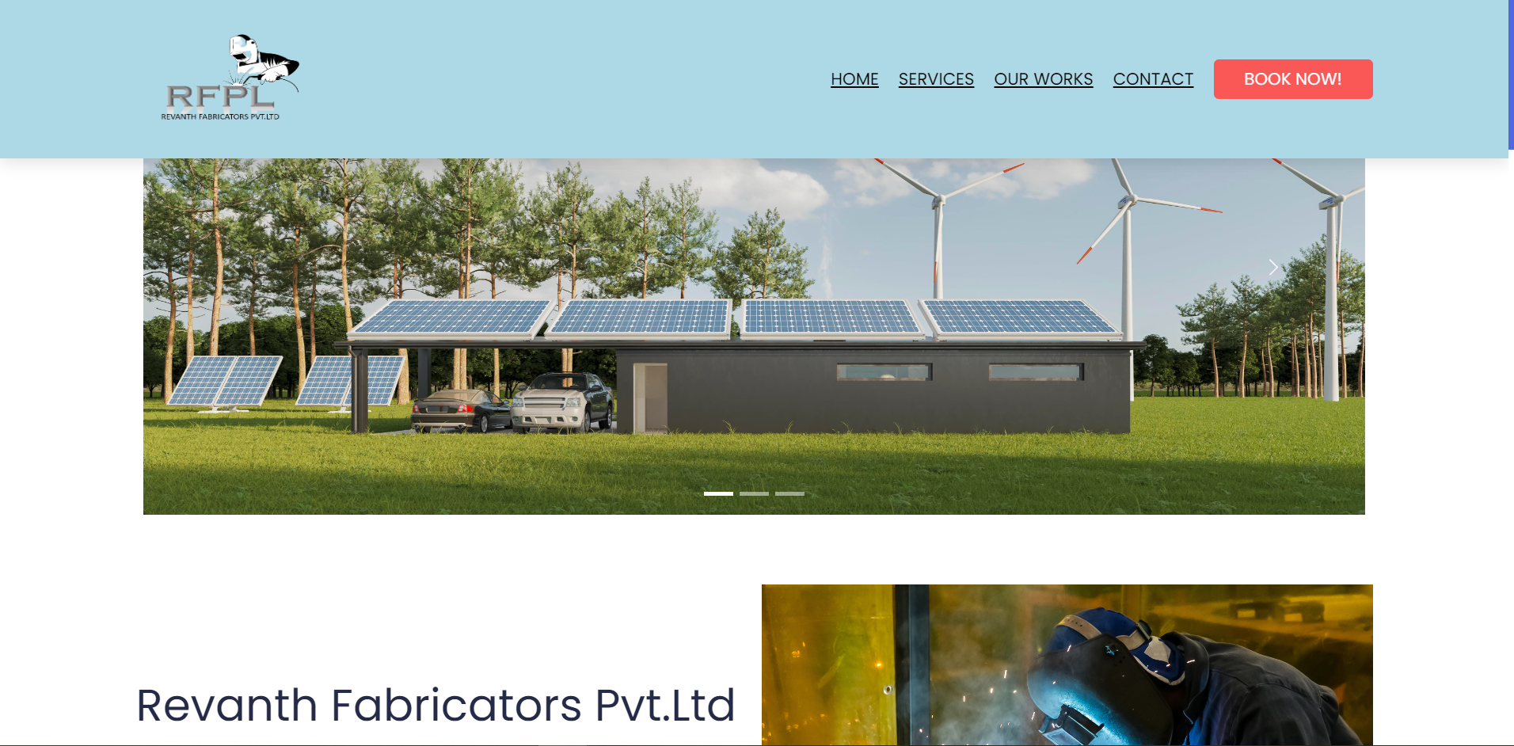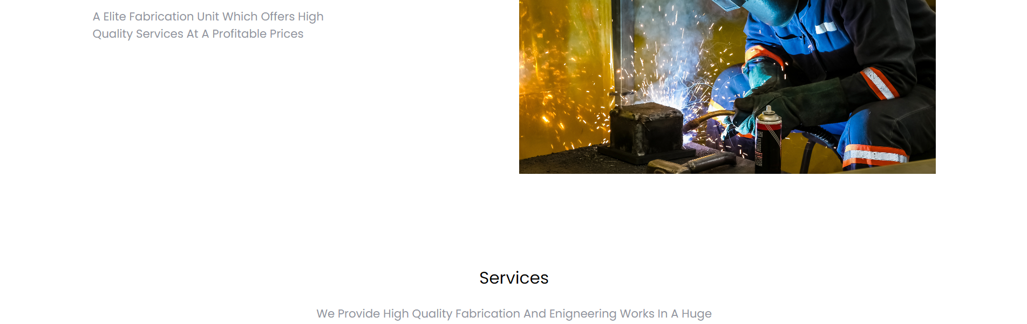

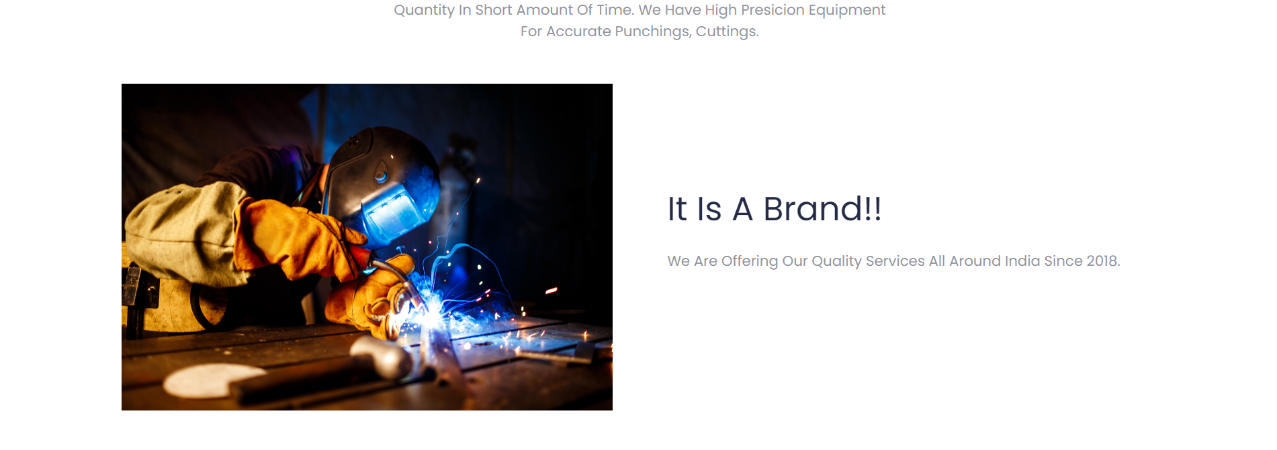





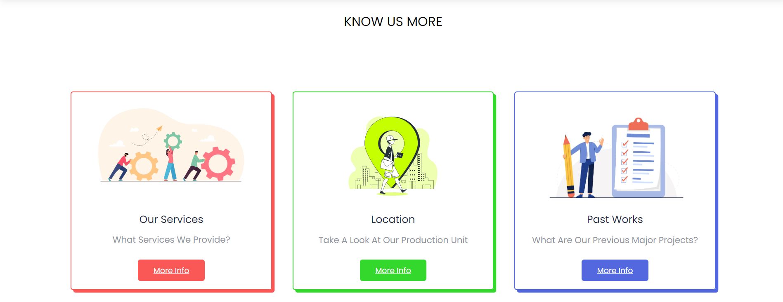

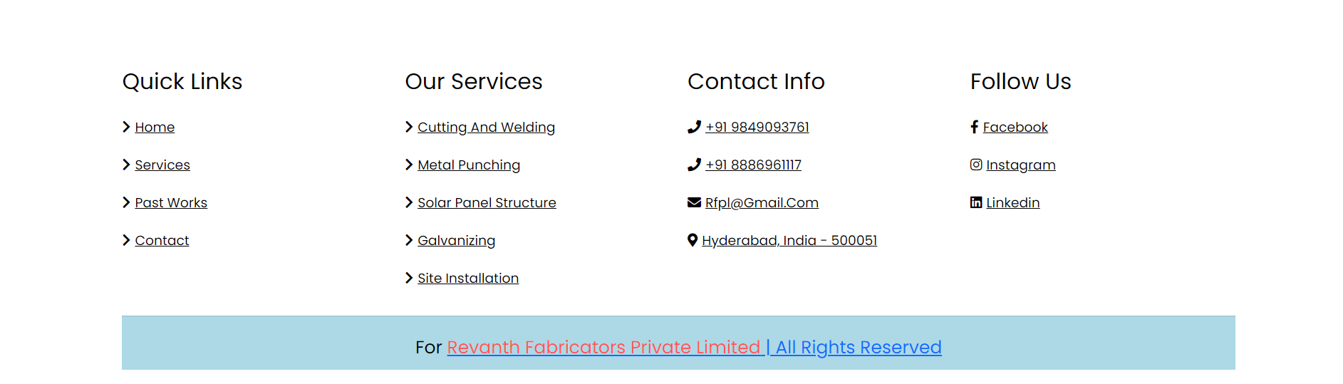

**Fig. 3**: Home page

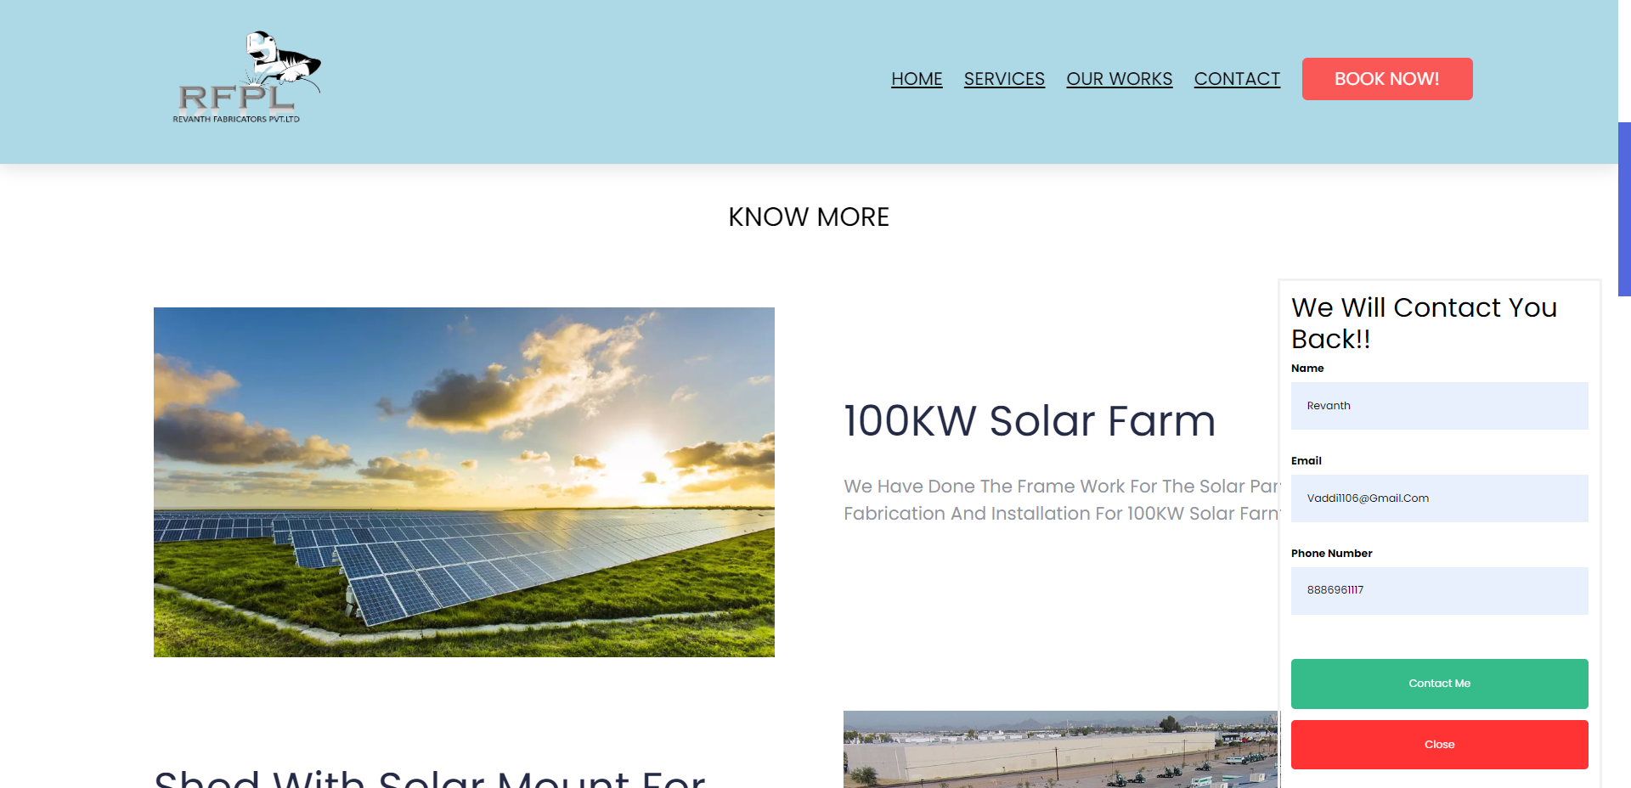

Fig.4.Pop-Up Form

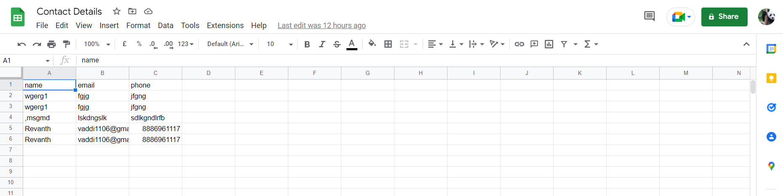

Fig.5.Google Sheets Database

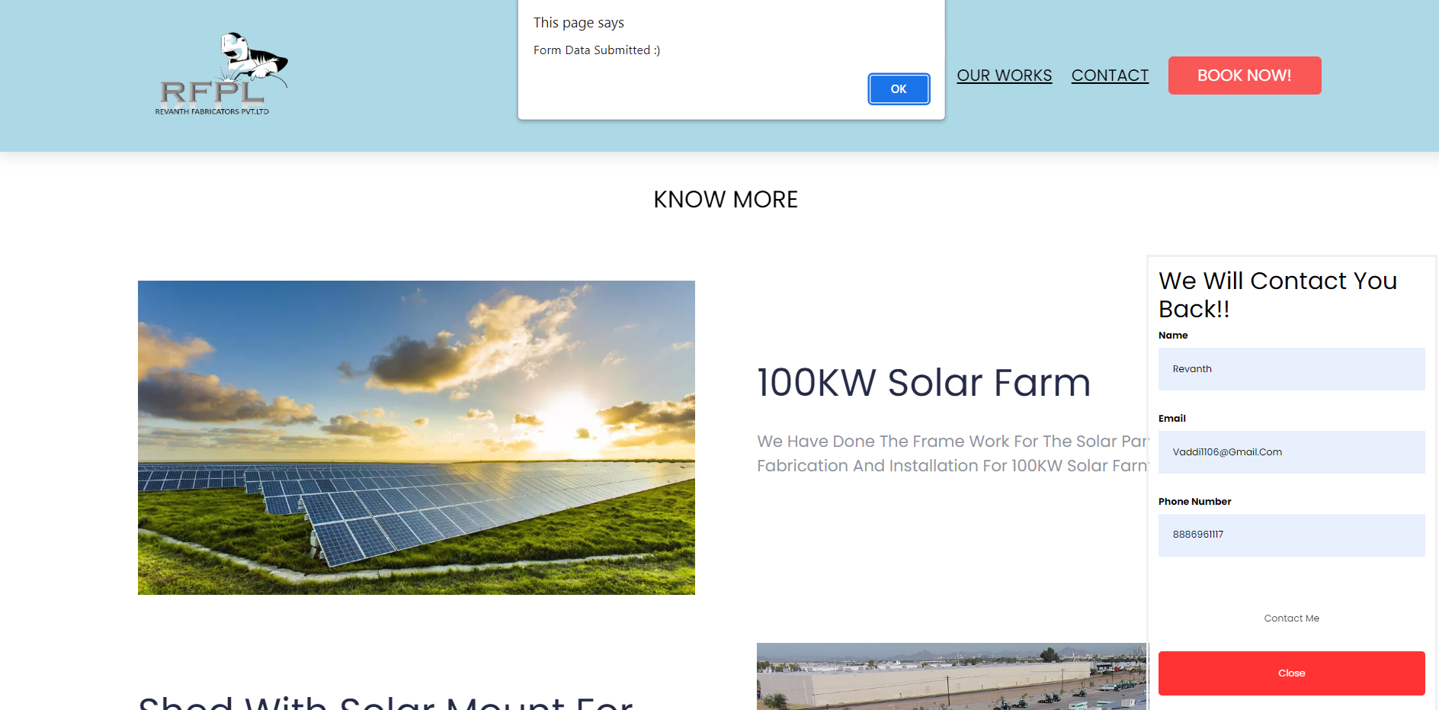

Fig.6.After Data Submission

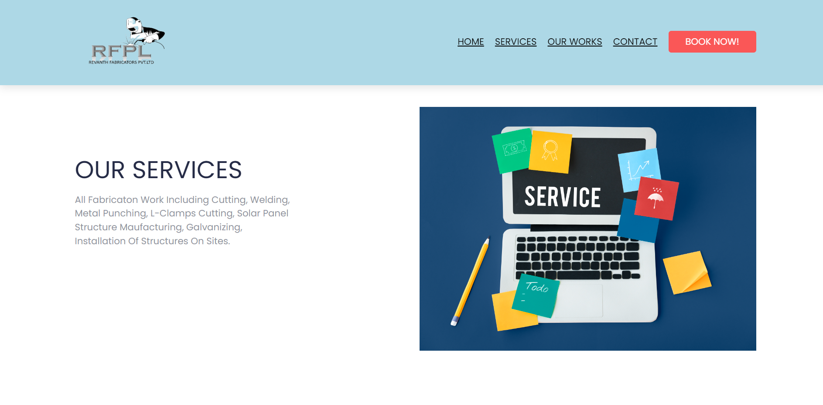

Fig.7.Services page

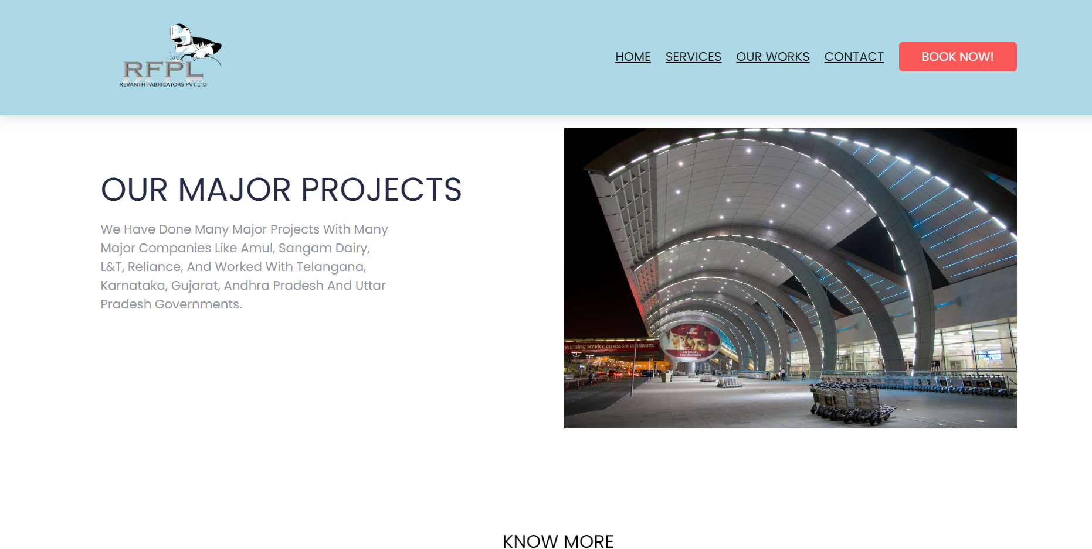

Fig.8.Our Works page

## Results

We developed a code for a website to display the company Profile, Past Major Projects, The Services it Provides, Navigation to their Production Unit, A form to collect the data of customers which will be stored in spreadsheets, and contact details of the company using HTML, CSS, Bootstrap, AOS Animation, and JavaScript.

## 

# CHAPTER -5

# CONCLUSIONS AND FUTURE WORK

**Conclusion**

We have successfully implemented and hosted the website for the Hyderabad-based fabrication company called Revanth Fabricators Private Limited. It acts as a Digital Promoter for the company. The company can also get the details of the customers who are interested to contact the company. The company can regularly update the website to have an updated profile of the company.

In the future, when the company expands its operations and production units the website will be modified in such a way that billing, Payments, and all the required orders can be taken from the website itself for the easy management of the company. This will be a successful Project as it is a major game changer for the company.

**CHAPTER -6**

**REFERENCES**

1. HTML 4.01 Specification W3C Recommendation 24 December 1999 (@ <https://www.w3.org/TR/html401/>).
2. <https://www.w3schools.com/html/>
3. <https://www.w3schools.com/css/>
4. <https://www.w3schools.com/js/>
5. <https://www.apispreadsheets.com>
6. Clinick, Andrew (July 14, 2000). "Introducing JScript .NET". Microsoft Developer Network. Microsoft. Archived from the original on November 10, 2017. Retrieved April 10, 2018. Since the 1996 introduction of JScript version 1.0 ... we've been seeing a steady increase in the usage of JScript on the server—particularly in Active Server Pages (ASP)
7. "HTML5: A vocabulary and associated APIs for HTML and XHTML". World Wide Web Consortium. 28 October 2014. Retrieved 31 October 2014.
8. Responsive Web Design with HTML5 and CSS by Ben Frain